**Verification Plan for Dhaka Mail Notification Application**

**(Host:** **1srasjavaapp3.mas.net)**

* Verify the log - Check for any unexpected error.

As you will be having the server access for this application – Check the logs with this

**ip- 10.221.4.34**

**logpath - /tomcat/apache-tomcat/logs/logs**

fdm_data_load.log file

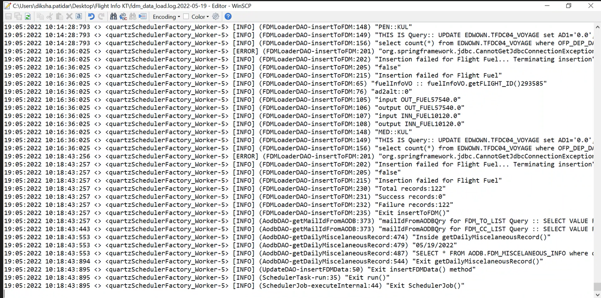

As we have validated the application and its working fine. Acknowledge the mail with the same.